Author(s):

Cyril Adjei 500695104

Annika de Graaf 500662415

Jast Hamelink 500693975

Abdel Ochan 500661495

Anthony Pang Kieuw Moy 500684932

Brian van der Raaij 500639928

Version: 0.2

Status: Concept

Date: 3 October 2014

ITopia is subsidiary of the

Hogeschool van Amsterdam

Version control

|  |  |  |  |  |
| --- | --- | --- | --- | --- |
| **Ver.** | **Status** | **Date** | **Author(s)** | **Changes** |
| 0.1 | Concept | 3-10-2014 | Anthony Pang Kieuw Moy | Added use case, scenarios and activity diagram |
| 0.2 | Concept | 3-10-2014 | Annika de Graaf | Grammar, and wireframes |
|  |  |  |  |  |

**Approval**

|  |  |  |  |  |  |  |
| --- | --- | --- | --- | --- | --- | --- |
|  | **Execution** | | **Inspection** | | **Approval** | |
| **Ver.** | **Name** | **Date** | **Name** | **Date** | **Name** | **Date** |
| 0.1 | Anthony Pang Kieuw Moy | 1-10-2014 | Annika de Graaf | 3-10-2014 |  |  |
|  |  |  |  |  |  |  |
|  |  |  |  |  |  |  |

Summary

In the functional design document we will explain what the overall design of our network configuration will look like. This document will contain the use case diagram, use case scenarios, an activity diagram and website wireframes.

Table of contents

1. Use Case Diagram 4

1.1 Diagram 4

2. Scenarios 5

2.1 Scenario 1 5

2.2 Scenario 2 5

2.3 Scenario 3 6

3. Activity Diagram 7

3.1 Diagram 7

4. Website Wireframes 7

# Use Case Diagram

This use case diagram will explain which actor can do which activity. In some cases both actors can do a certain activity. The two actors are defined as stick-figures and the use cases are defined as activities.

## Diagram

# Scenarios

When building a complex system, things can and will go wrong. That’s why we have described a few scenarios of things which could happen.

## Scenario 1

**Use Case** Forgotten password  
 **Primary Actor** User

**Preconditions** User is on the website

**Success Guarantee** The user knows what his or her forgotten password is.

**Main Success Scenario**

1. The user clicks on the button ‘’Forgot password’’.
2. The user enters his/her email address.
3. The user clicks on send to continue.
4. The user receives an email for confirm.
5. The user opens the mail with a link which direct the user to a page where he/she can change his/her password.
6. The user clicks on the underlined text ‘’ click here for a new password‘’.
7. The user successfully finished the tutorial ‘’ forgot password’’.

**Extensions**

3a. The user clicks wrong

2. The user clicks on ‘’login”.

4a. The user entered an invalid email address.

1. The user edits the email address.

## Scenario 2

## Scenario 3

.

# Activity Diagram

This activity diagram will be a follow-up on the previous chapter. We will visualise the steps a customer has to take to do specific tasks. We will give a visualisation of what a customer can do.

## Diagram

## 

# Website Wireframes

The front page of the website:

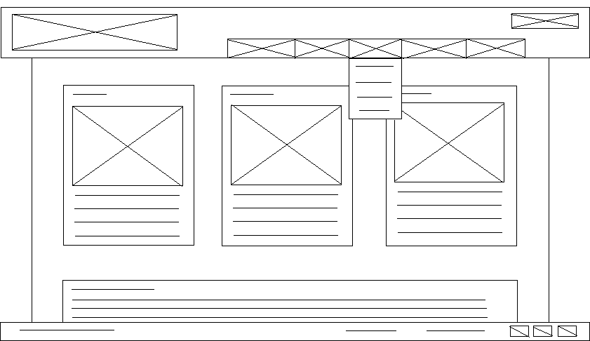

The top part, the header, exists of three separate elements. These elements are the logo, the menu and the login button.

**The logo** is the first element on the top left. This is the obvious choice in terms of placement for the logo as it is usually where people start reading (top, left).

**The menu** is placed at the top as well, so that it is easily to navigate through the website and to the page where the customer is looking for. A feature of the menu is that it will become a drop down menu, so that there are more choices underneath each menu option.

**The login** button will redirect the user to a different page, on which they can login. More details about the login page will be described underneath the second wireframe.

In the middle of the page, all the content will be placed. This consists of two main elements.

**The three columns** which are going to contain the different service levels Plaintech UK will offer their clients, putting them right at the top of the main content will make them very visible and makes the customers more prone to look at them.

**The main text field** in which information will be presented to the customers.

At the very bottom of the page there is a footer. The footer usually contains the name of the page, copyright details and sometimes more links. The footer in the wireframe consists of two elements.

**The copyright details** are located on the footer so that it will be known Plaintech UK is the owner of all information on their website.

**The (social media) links** are also located on the footer so that people can look Plaintech UK up and connect with them on more webpages.

The login page of the website:

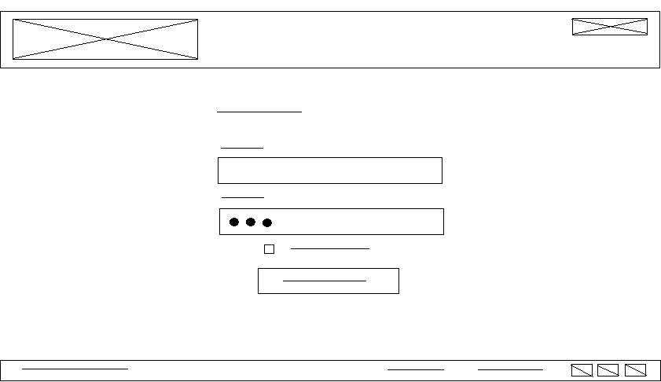

The login page of the website will obviously be in the same style as the front page of the website and all other pages, however this page does not contain the menu as this page works slightly different. The page grants access to the virtual machine as the user will be logged on the user panel here.

Since the **header** and the **footer** did not change aside from the lack of menu, we will only explain the main content.

The main content consists of four elements. The username input field, the password input field, the check box and the continue button.

**The username input field** is basically a plain text input box where the user is meant to type their username so that it can be compared to the database.

**The password input field** is a text input box where instead of the actual characters it will show dots to protect the user from people that might look at their screen. This is one of the most basic forms of security we will implement.

**The check box** is there to allow users to use the ‘remember me’ option, which will basically allow their browser to remember the username and password for them so that they do not have to put them in every time they want to login, even though this is not recommended.

**The continue button** is placed underneath the other elements since this is the last thing the user has to click on before they can continue. Pressing the button will initialise a connection with the database so that the username and password can be compared to the ones stored in the database. If they are the same, access to the control panel is granted.